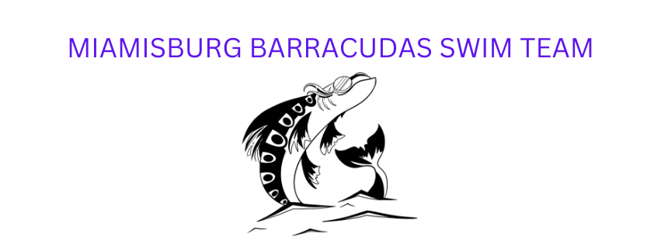
Dear Sponsors,

The Swim Association of Miamisburg (Miamisburg Barracudas) is a prominent youth organization in our community, and has developed young swimmers for over 40 years. As an organization, we have encouraged generations of local swimmers to nurture their love for swimming. We pride ourselves on the fact that we develop such a love of the sport, many of our swimmers come back to the organization as coaches and parents. As our 2025 swim season quickly approaches, we are excited to invite you to become a part of our sponsorship program!

Your financial support is a very important part of our team. This year, we are facing some continued challenges with the temporary closure of our home pool, the Sycamore Trails Aquatic Center, and we are continuing to keep team fees affordable for our swimmers and their families. As a result, we are relying on businesses and organizations in our community to help us to continue providing this opportunity to our swimmers. The generosity of our sponsors helps us to pay for the pool space, coach salaries, and league and championship fees. Any monetary amount donated from our sponsors is greatly appreciated! All donations are tax deductible!

All sponsors will receive a personalized thank you note form the Miamisburg Barracuda swim team. We have a few support options that will also provide advertising for your business.

GOLD SPONSORSHIP: $300 (Full Page ad in the Championship brochure, your logo on the team banner, a social media shoutout, and your logo on our website)

SILVER SPONSORSHIP: $200 (Your logo on the team banner, a social media shoutout, and your logo on our website)

BRONZE SPONSORSHIP: $100 (A social media shoutout and your logo on our website)

Our swimmers appreciate your support, and we look forward to having you as a member of our team for the 2025 swim season.

Kate Quackenbush Krissy Cornette
Miamisburg Board President Fundraising Chair

CORPORATE SPONSOR REGISTRATION FORM

GOLD SPONSOR: $300
- Full Page Ad in the SOSL Championship Heat Sheet, this is seen by 500 swimmers and their families in the Dayton Area
- Large Logo on the 2025 Team Banner
- Shout out on the Miamisburg Barracuda Facebook Page
- Logo on our Website

SILVER SPONSOR: $200
- Logo on the 2025 Team Banner
- Shout out on the Miamisburg Barracuda Facebook Page
- Logo on our website

BRONZE SPONSOR: $100
- A Shout out on the Miamisburg Barracuda Facebook Page
- Logo on our website

SPONSOR/COMPANY NAME: ___________________________________________________

CONTACT NAME (if other than sponsor): ___________________________________________

SPONSORSHIP LEVEL: ______________________ PHONE: _________________________

ADDRESS: __________________________________________________________________

Payments MUST be received by May 15th to be included on this year’s banner.
For questions or more information, please contact Krissy Cornette at 317-432-1367 or miamisburgbarracudaswimteam@gmail.com.

Please remit your payment to: Swim Association of Miamisburg, P.O. BOX 1073, Miamisburg, OH 45343.

