Miamisburg Barracudas

Zink's Sub Fundraiser
SUB ORDERS ARE DUE ON THURSDAY, JUNE 5TH
CASH, VENMO (@MiamisburgBarracudas), CHECK (Swim Association of Miamisburg)
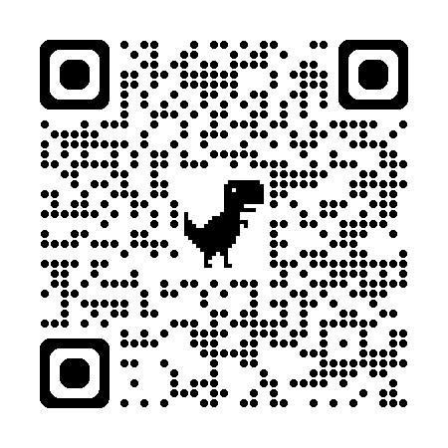
We are selling Zink's Italian sub sandwiches again this season!
Italian sub sandwiches are made by hand and come with:
- 3 one oz slices zesty loaf, salami, and beef & pork loaf
- 1 slice American cheese
- banana peppers
- pizza sauce (Optional: No Sauce)

Important Dates:
- Sell May 8 - June 5th
- Submit Orders via Google forms by June 5th (even if your family is choosing the buyout option) using the QR Code above
- Sub Pick-up: Wednesday, June 25th at 7 PM at St. Jacob’s Church

Cost: $6/Sub

Fundraiser requirement: Every FAMILY is asked to sell 10 subs. Don't want to sell, that's fine! We are just asking for a $30 buyout fee from each family.

TOP SELLER: The swimmer who sells the most subs will get a shoutout on the Facebook page and a small treat from the team.

Name | Phone Number | # Subs  (As is) | # Subs  (No Sauce) | Amount Due | Paid
TOTAL

